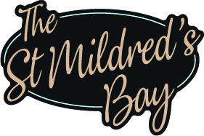
Pre-Order: Form to be sent to mia@thestmildredsbay.com

1 Week before the booking.

  - St Mildreds Bay Festive Menu Pre-Order as Stated on Menu:
Party Name |  | Party Size |  | Date of Booking

Please complete the form below for your festive meal pre-order. List each guest’s name, their starter, main, and dessert choice. If anyone has any allergies or dietary requirements, please clearly state their name and the specific allergy or requirement in the section provided at the bottom.
Name | Starter | Main | Dessert

Please write below if you have any allergies or dietary requirements. Include the name of the person and details of the allergy or requirement:
Name |  | Allergy/Requirement
Name |  | Allergy/Requirement
Name |  | Allergy/Requirement
Name |  | Allergy/Requirement
Name |  | Allergy/Requirement
Name |  | Allergy/Requirement
Name |  | Allergy/Requirement
Name |  | Allergy/Requirement
Name |  | Allergy/Requirement
Name |  | Allergy/Requirement

